
MASTER OF BUSINESS ADMINISTRATION (FINANCE) 2024 – 2026
INTERNSHIP REPORT

S.N. | NAME OF PARTICIPANT | COMPANY
1 | 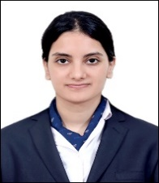  Aakanksha Vatsa | 
2 | 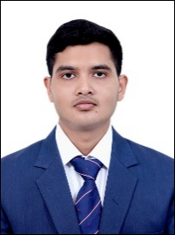  Arjit Shrivastava
3 | 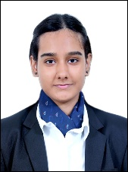  Harpreet Kaur
4 | 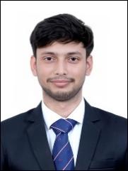  Shivam Kumar Singh
5 | 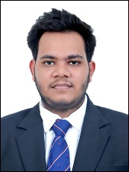  Vaibhav Kumar
6 | 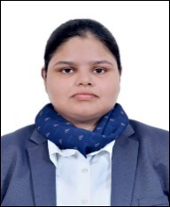  Vanshika Singh
7 | 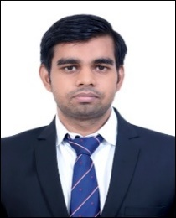  Vivek Kumar
8 | 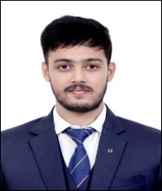  Akshit Antony |   Odisha Capital Market & Enterprises Limited
9 | 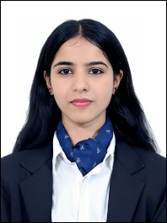  Isha Bagoli
10 | 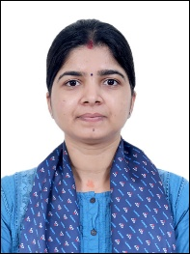  Kanchan Pandey
11 | 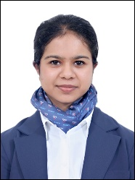  Manika Gupta
12 | 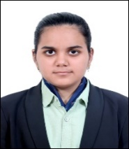  Pankhudi Tripathi | Odisha Capital Market & Enterprises Limited
13 |   Ashmit Basu | 
14 | 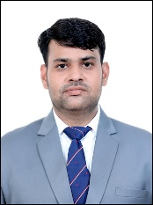  Harvendra Pratap Singh
15 | 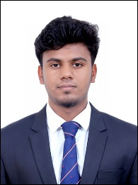  Santosh CH
16 | 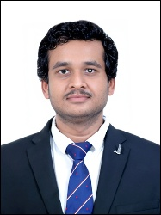  Varun Palrecha
17 |   Sakshi Sharma | 
18 | 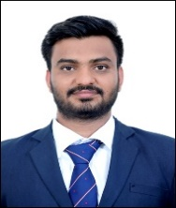  Sharad
19 |   Tentu Shashidhar
20 | 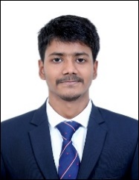  Divesh Vibhakar |   Power Finance Corporation Limited
21 |   Mansi Patel
22 |   Tushar Mishra
23 | 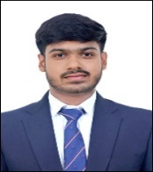  Atul Kumar | 
24 | 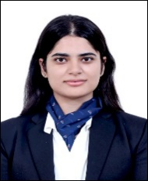  Chahak Khera
25 | 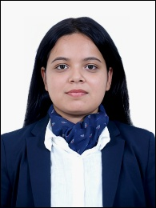  Nimisha Singh
26 | 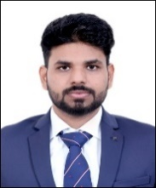  Hindesh Kumar |   InvestMyFunds
27 | 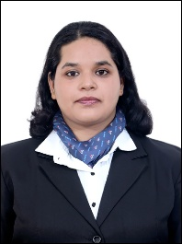  Simiran Mohapatra
28 | 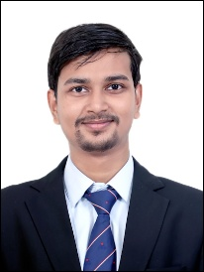  Vivek Ojha
29 | 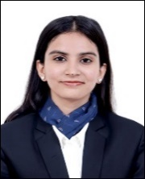  Anushka Sinha |   IFCI Limited
30 |   Ipsa Sehgal | IFCI Limited
31 | 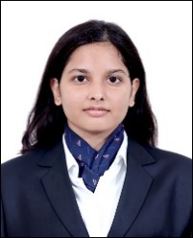  Arkaja Joshi |   MCQube
32 | 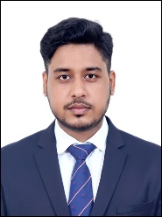  Ashish Raj
33 | 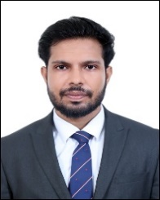  Anuj Pal | Use the "Insert Citation" button to add citations to this document.    Galactico Corporate Services Limited
34 | 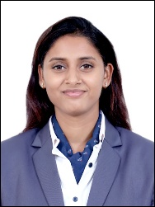  Komal Srivastava
35 |   Jhanvi Mishra | 
36 | 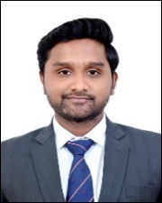  Priyanshu Agarwal
37 | 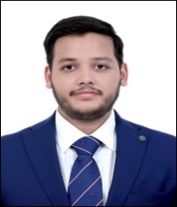  Ankur Goyal |   Green Portfolio Private Limited
38 | 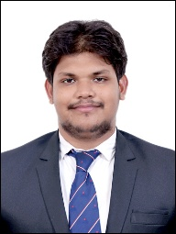  Chidananda Mohanty
39 |   Neeraj Mishra |   Steel Authority of India Limited
40 | 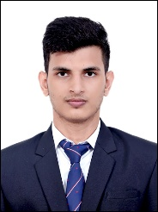  Deepak Singh Chauhan
41 | 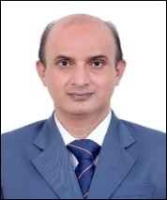  Mukesh Kumar | 
42 |   Shrishti Saxena |   Religare Broking Limited
43 |   Shruti Gupta | 
44 |   Sakshi Chaturvedi | 
45 | 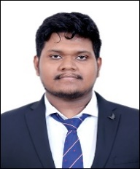  Swadhin Barad | 
46 |   Dewang Supekar | 
47 | 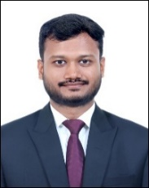  Shubham Priyadarshi |   DefinEquity Investment Managers
48 | 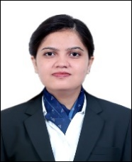  Muskaan | 
49 | 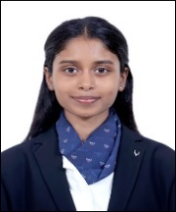  Gargesha Sreya Divvela | 
50 |   Himanshu Dangi |   REC Limited
51 |   Rashmi Shukla | 
52 | 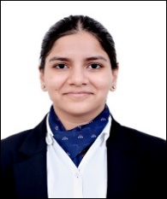  Subarna Satapathy |   Mahanadi Coalfield Ltd.
53 | 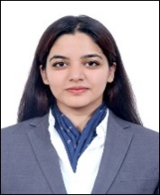  Divya Badguzar |   Aditya Infotech Ltd.
54 | 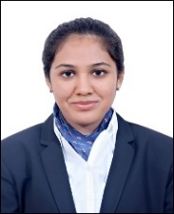  Yashvi Jain |   Canara HSBC Life Insurance Company Ltd.
55 | 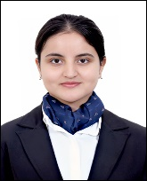  Mradushi Shukla | NIMISHA ASHISH & ASSOCIATES  Chartered Accountants

SUMMER INTERNSHIP SUMMARY
TOTAL STUDENTS | 55
TOTAL NUMBER OF COMAPNIES | 28

